
INFOST 440
Final Project Grading Scheme

Due Date Wednesday, December 14th, 2016 11:59 PM

Overview:

Here are the grading criteria for the final project. Limited help will be offered during this project since it is a chance for you to show what you have learned.

Copying my prototype and making it work on your server: up to 10 points.
- Registration (4 points)
- Login/Logged-in/Logout (4 points)
- Home (1 point)
- Links (1 point)
* All the pages should work on your Web site.

Additional TWO items only available for those who log in: 6 points
- My Bookmarks (4 points)
- Contact us (2 points)
* Everything should work without losing the session all the time.

Overall design (4 points total)
- Different/enhanced header layout: 1
- Different/enhanced footer layout: 1
- Different/enhanced home (index.php) layout: 1
- Useful Theme/Content (Quality): 1

Total possible points: 20

Here is what the basic template looks like. You are asked to make some enhancements to this template:

This is what you are supposed to see before LOGIN:

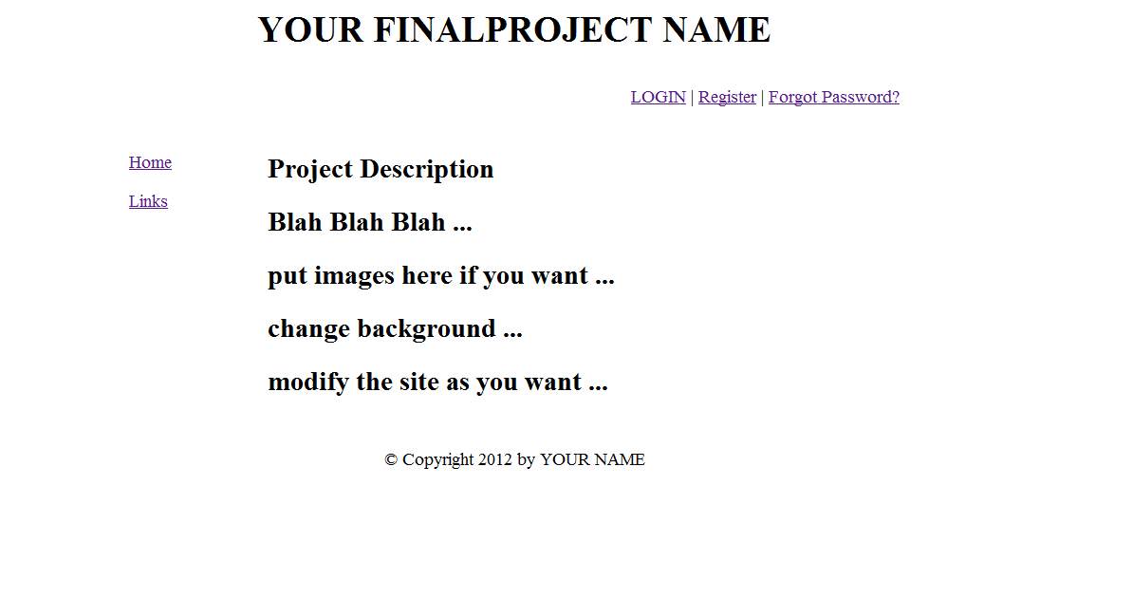

This is what you are supposed to see after LOGIN:

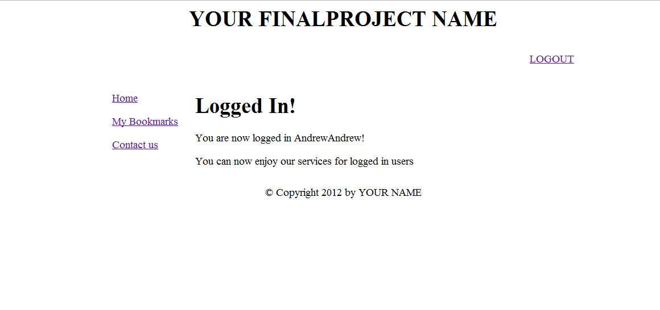

INSTRUCTIONS

- Download all the files (Project.zip) from Week 13 on D2L.

- All the scripts for this project are provided to you. However, if you try to run the downloaded scripts before modifying them, they will not run correctly. You need to modify the scripts so that your web site runs and works correctly. Use this opportunity of modifying the scripts to read and understand the code in the scripts so you can modify the code easily. I know students who took this course in previous semesters and they still go back and use these scripts. Us this project as a good learning experience and try to add your own enhancement to it.

- For mysql_connect.php, you need to modify the username, password, database name the same way you did for week 13 assignment.

- Modify and enhance the prototype template!!!
- Decide your theme. (e.g. Wisconsin travel guide, Milwaukee Brewers, etc.)
- Change the title, home, and add relevant content to your theme.
- Modify index.php, header.php, footer.php and other files as needed according to your theme and also according to the folder structure mentioned below in step 6
- Add more than six relevant records in your bookmark page.
- Modify “contact us” page.
- You may want to add more pages (optional).
- You may want to create more MySQL tables (optional).

5. Create a folder, “public_html/Project/”, for the final project on your server.

6. Upload all the files to “public_html/Project/” using FTP.
(important) Your project folder structure on the web server should follow the project folder structure which can be seen in the following screen shots:

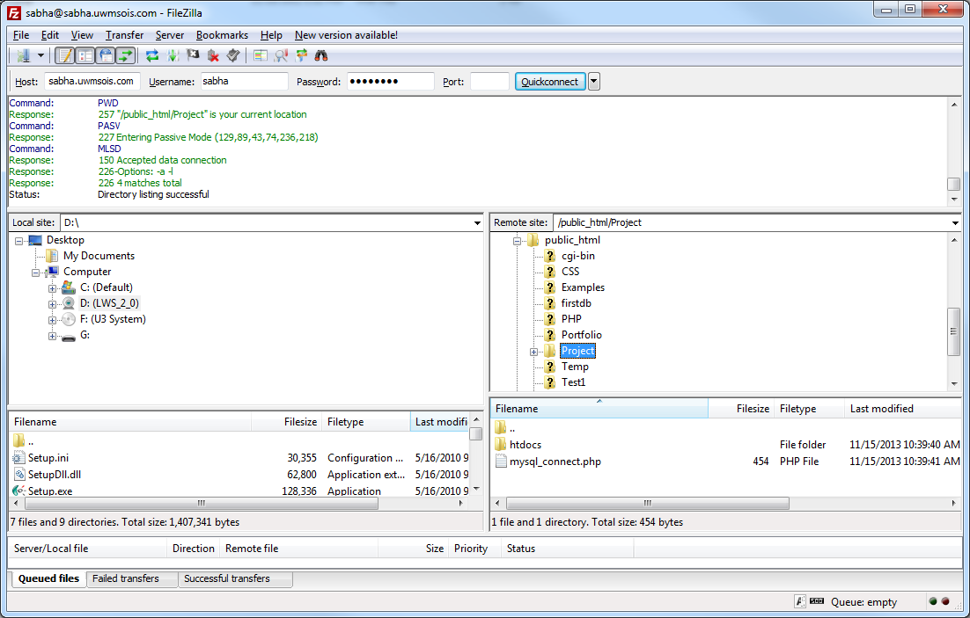

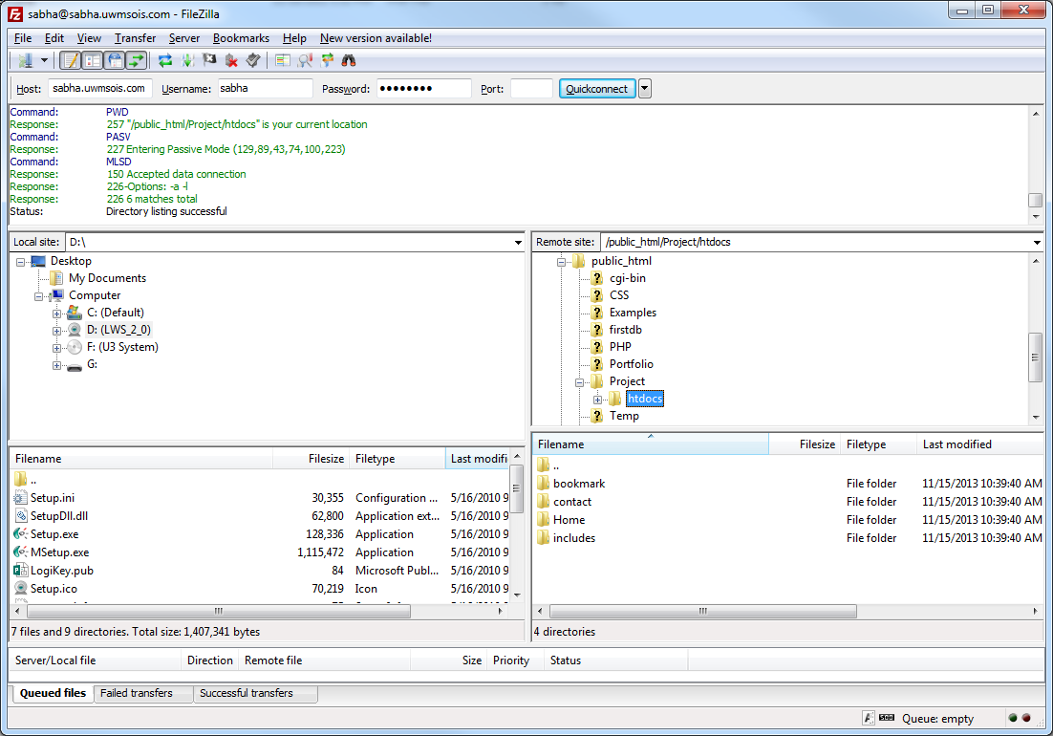
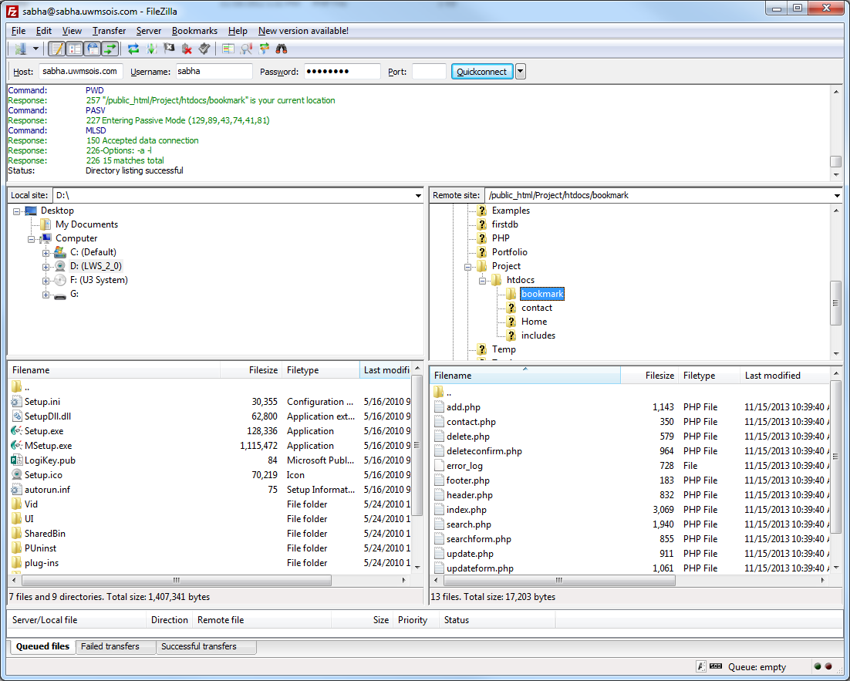

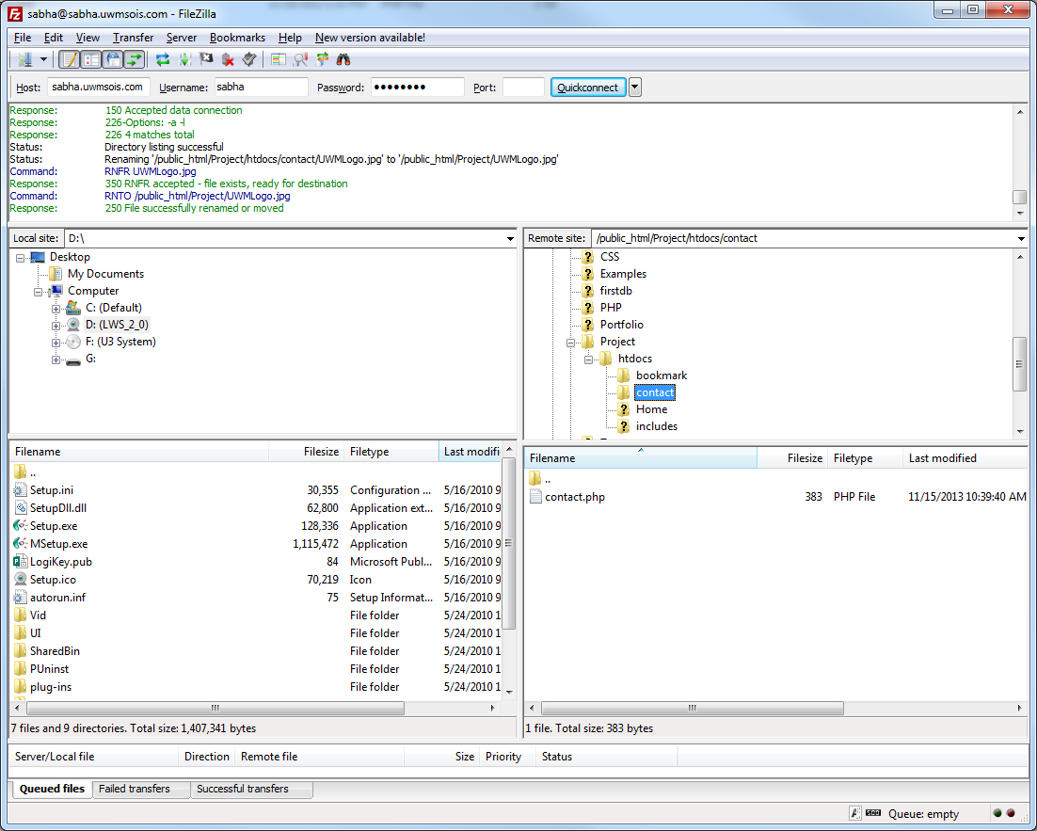

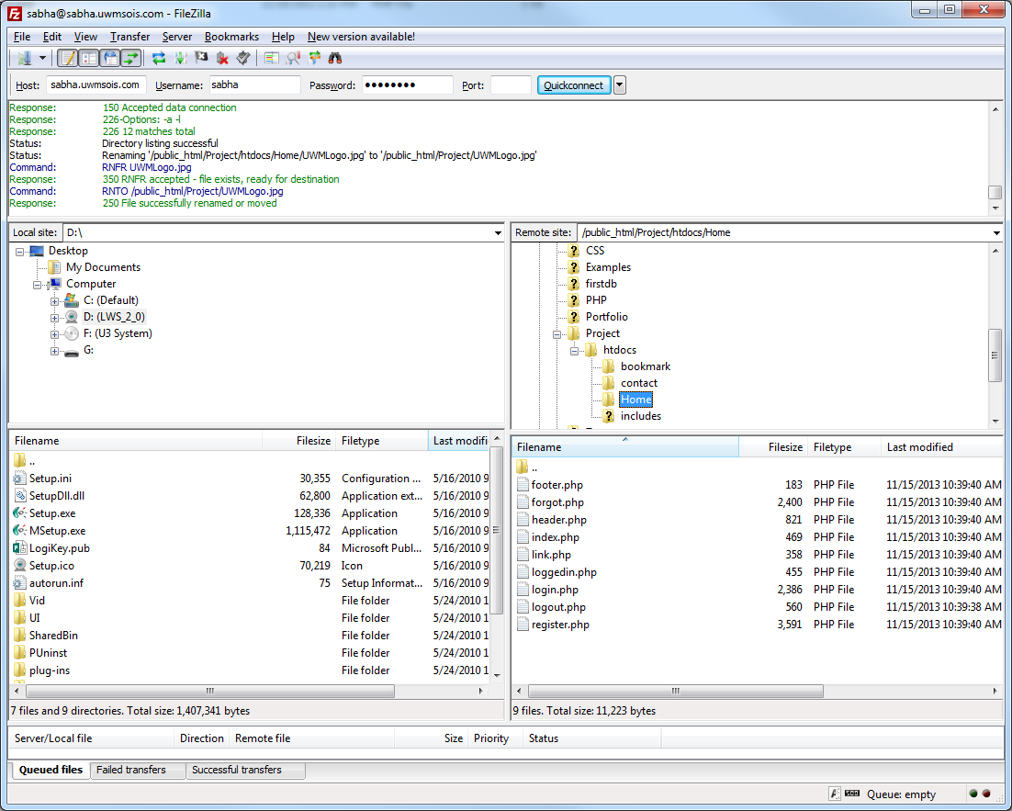

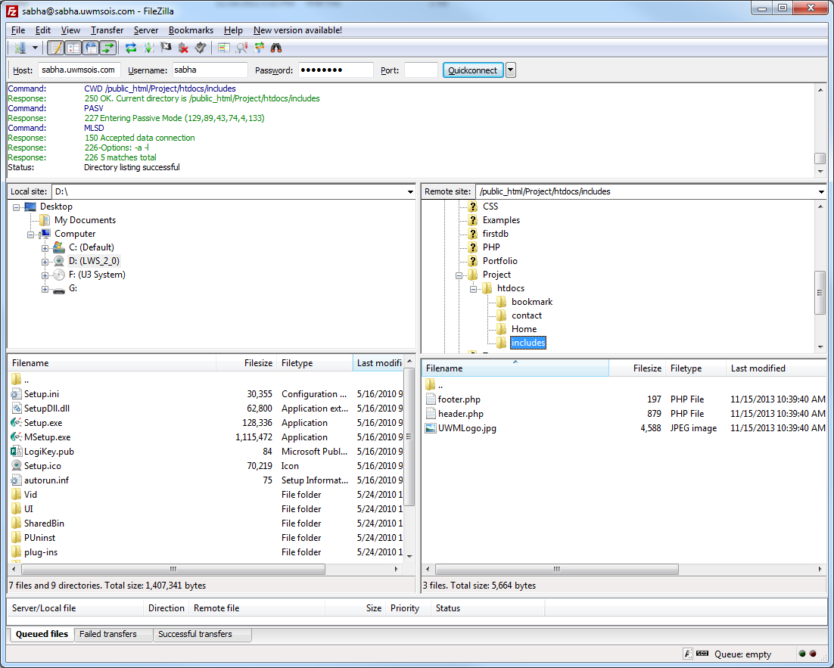

7. To add a new page that can be accessible only after logged in, please do the following:

- Start the session and add session information ($_SESSION[‘email’] at the beginning of the code as below

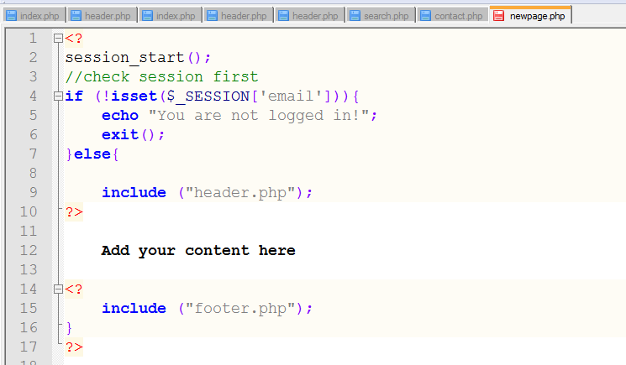

- Add a hyperlink to a new page in your header files as below:

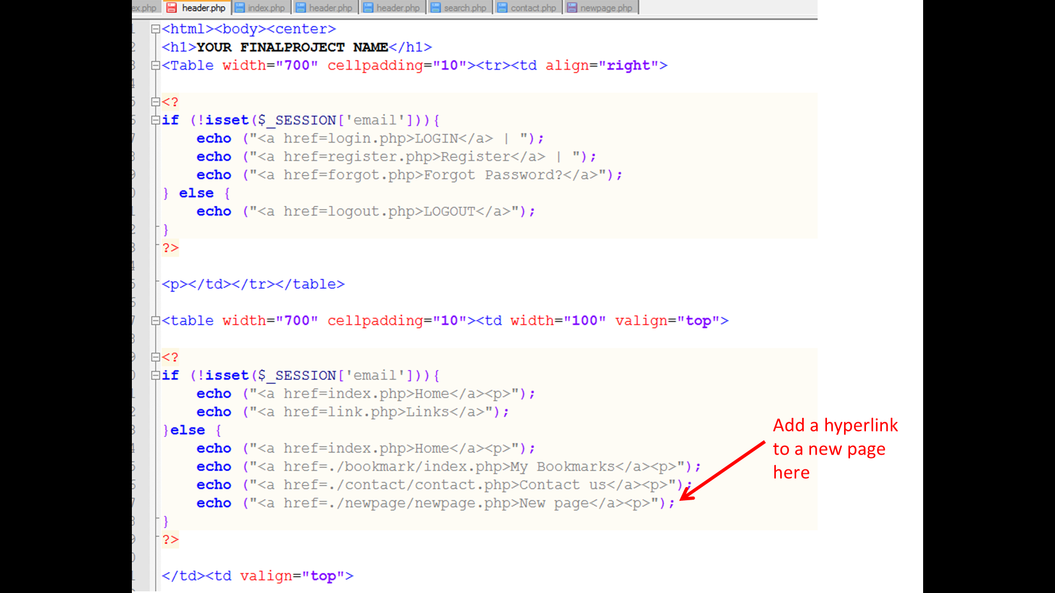
8. I have created a basic web site which implements this project. Take a look at that to get a feeling of what you need to do for the project in case you still have questions. Be creative and add your own enhancements to the project. When you go to my web site, register as a new user and then login. The URL for that web site is:

http://sabha.uwmsois.com/Project/htdocs/Home/index.php

9. When you are done with the porject, copy the link to your project in a text file and upload that text file to the Project drop box on D2L. Also, upload screen shots of file Zilla that show your project structure similar to the screen shots I have under step 6 above.

